### 

### Semester Two Examination, 2019

### Question/Answer booklet

# Yr 12 SPECIALIST

**UNIT 3 & 4**

## Section Two:

## Calculator-assumed

|  |
| --- |
|  |

Your Name

Your Teacher’s Name

## Time allowed for this section

Reading time before commencing work: ten minutes

Working time: one hundred minutes

## Materials required/recommended for this section

***To be provided by the supervisor***

This Question/Answer booklet

Formula sheet (retained from Section One)

***To be provided by the candidate***

Standard items: pens (blue/black preferred), pencils (including coloured), sharpener, correction fluid/tape, eraser, ruler, highlighters

Special items: drawing instruments, templates, notes on two unfolded sheets of A4 paper, and up to three calculators approved for use in this examination

## Important note to candidates

No other items may be taken into the examination room. It is **your** responsibility to ensure that you do not have any unauthorised material. If you have any unauthorised material with you, hand it to the supervisor **before** reading any further.

|  |  |  |  |  |  |
| --- | --- | --- | --- | --- | --- |
| **Question** | **Marks** | **Max** | **Question** | **Marks** | **Max** |
| **8** |  | **4** | **15** |  | **9** |
| **9** |  | **8** | **16** |  | **8** |
| **10** |  | **9** | **17** |  | **8** |
| **11** |  | **7** | **18** |  | **9** |
| **12** |  | **7** | **19** |  | **7** |
| **13** |  | **7** | **20** |  | **7** |
| **14** |  | **10** |  |

**Structure of this paper**

|  |  |  |  |  |  |
| --- | --- | --- | --- | --- | --- |
| Section | Number of questions available | Number of questions to be answered | Working time (minutes) | Marks available | Percentage of examination |
| Section One:  Calculator-free | 7 | 7 | 50 | 51 | 34 |
| Section Two:  Calculator-assumed | 13 | 13 | 100 | 100 | 66 |
|  |  |  |  | **Total** | 100 |

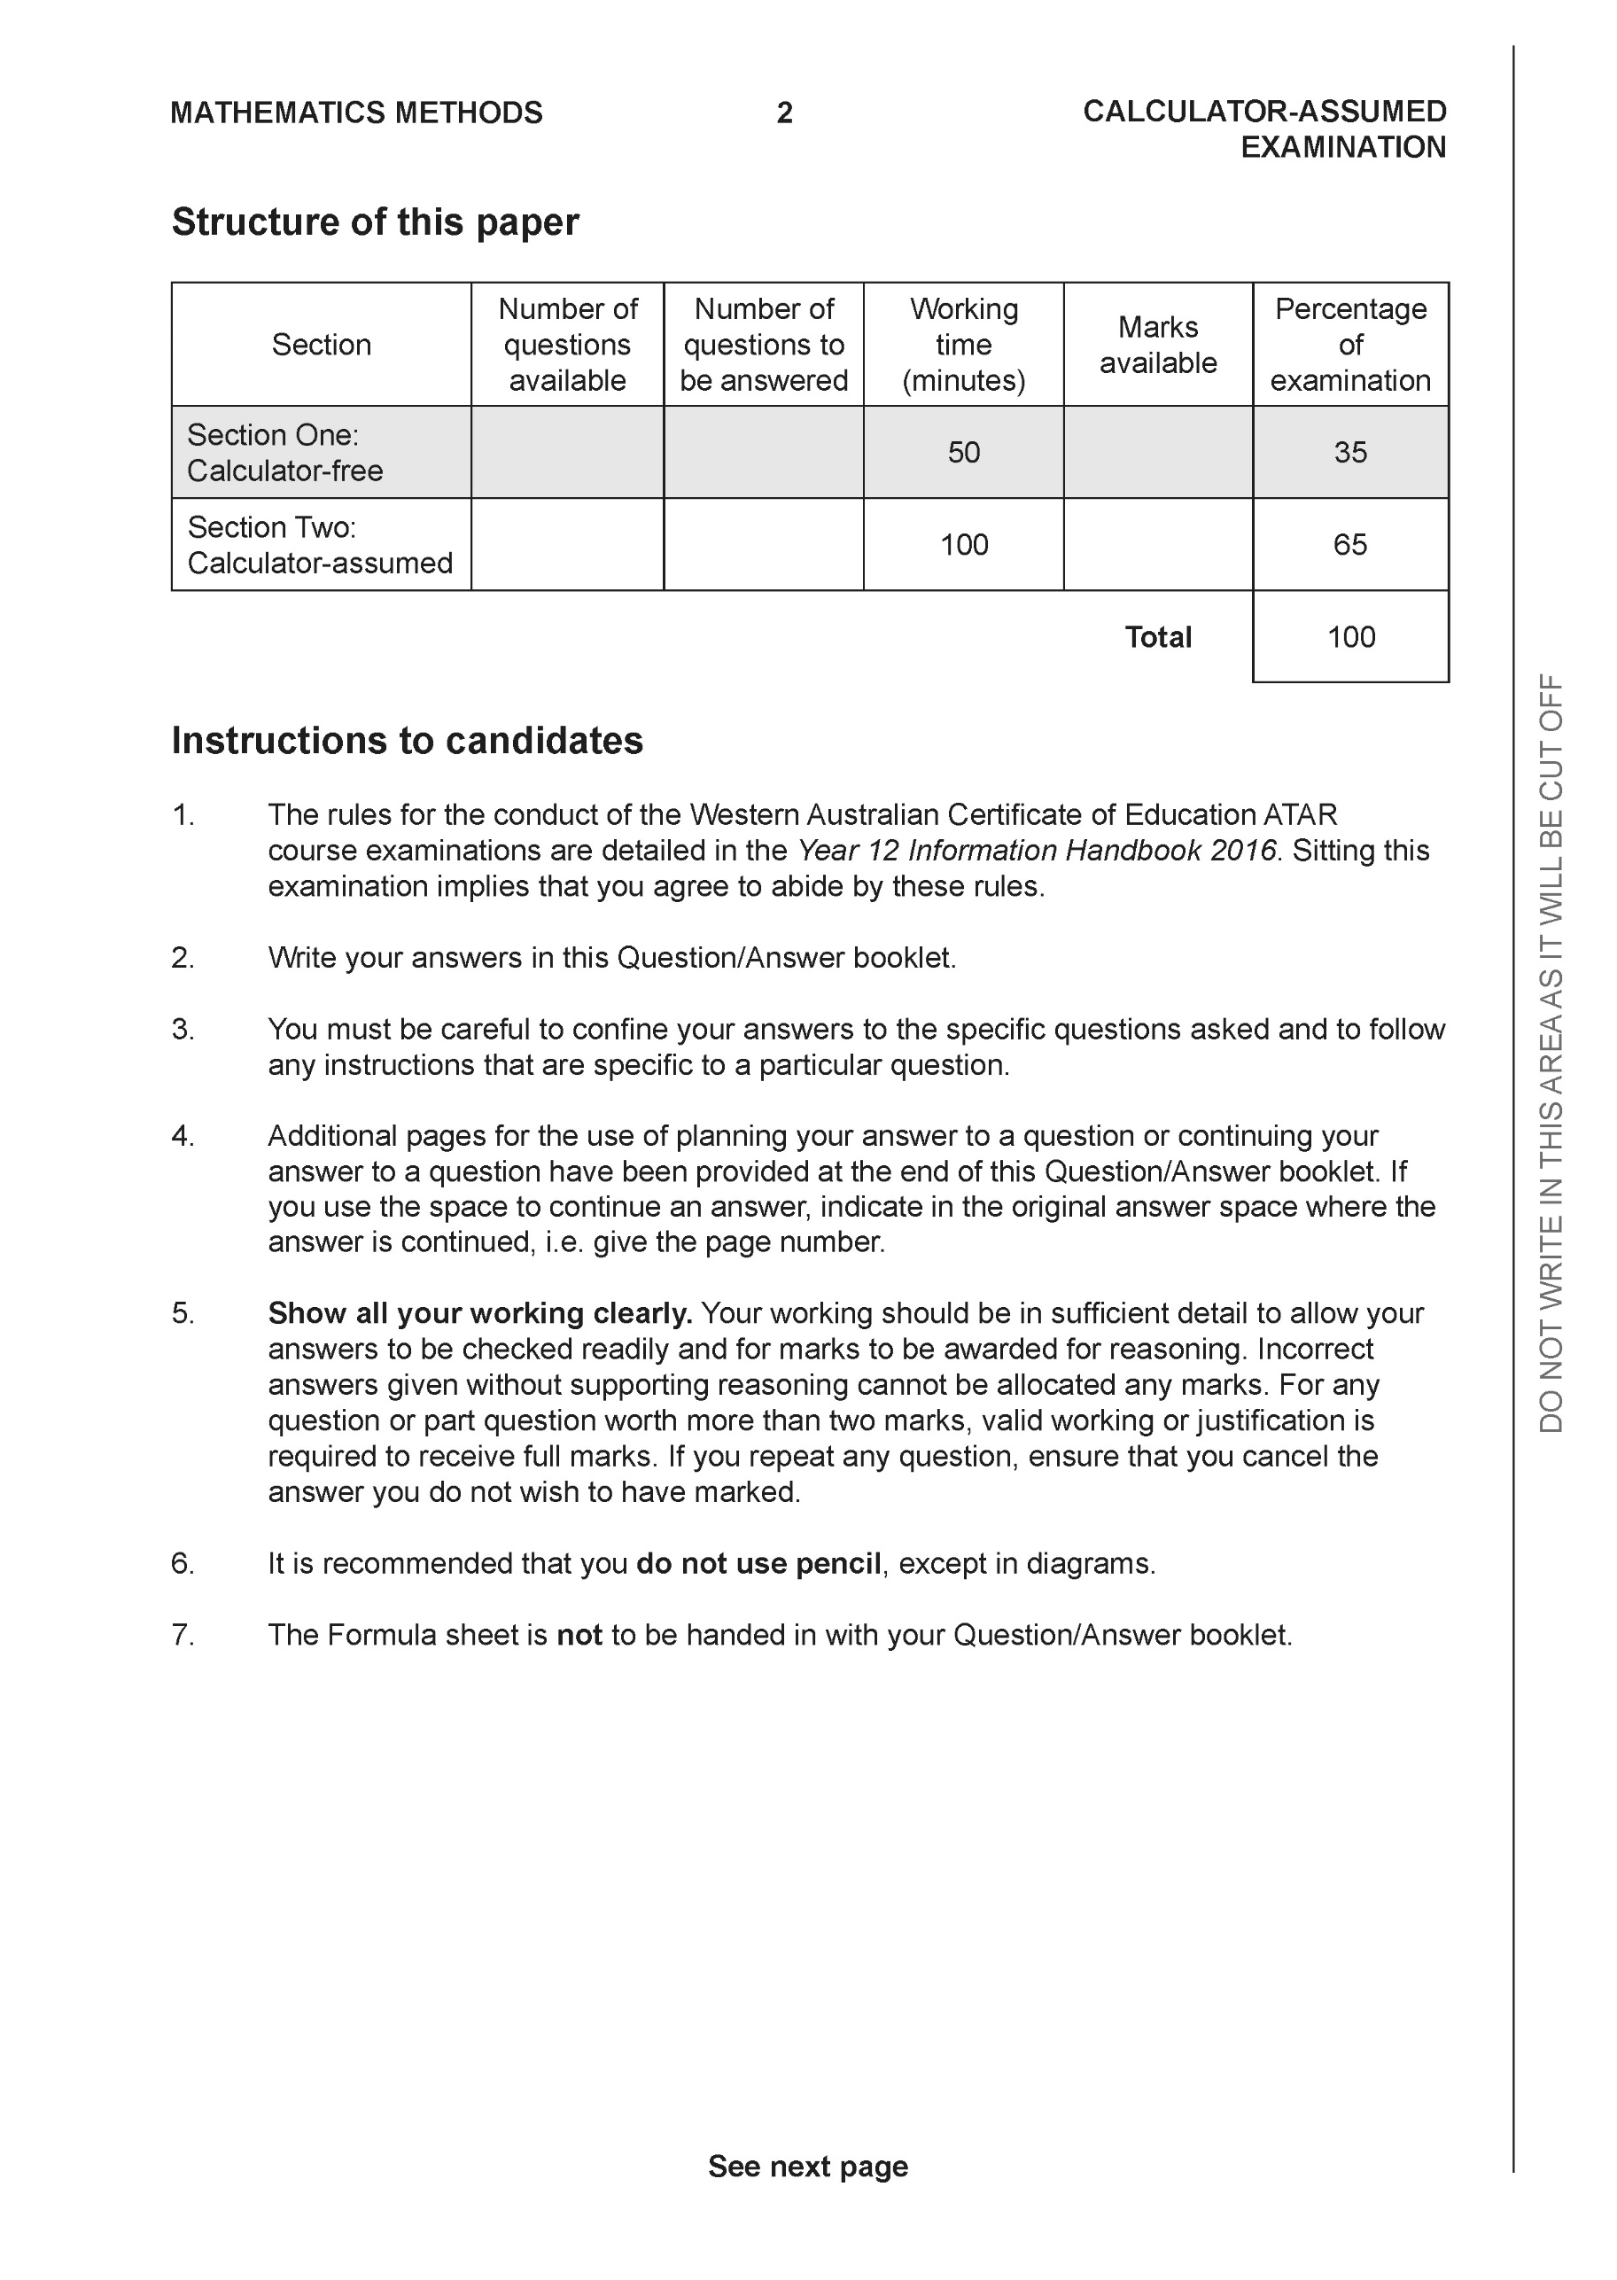

**Section Two: Calculator-assumed (100 Marks)**

This section has **13** questions. Answer **all** questions. Write your answers in the spaces provided.

Spare pages are included at the end of this booklet. They can be used for planning your responses and/or as additional space if required to continue an answer.

● Planning: If you use the spare pages for planning, indicate this clearly at the top of the page.

● Continuing an answer: If you need to use the space to continue an answer, indicate in the original answer space where the answer is continued, i.e. give the page number. Fill in the number of the question that you are continuing to answer at the top of the page.

Working time: 100 minutes.

**Question 8 (4 marks)**

Consider the complex number . By using De Moivre’s theorem show that 

**Question 9 (8 marks)**

Sketch the following regions in the complex plane.

1.  (2 marks)

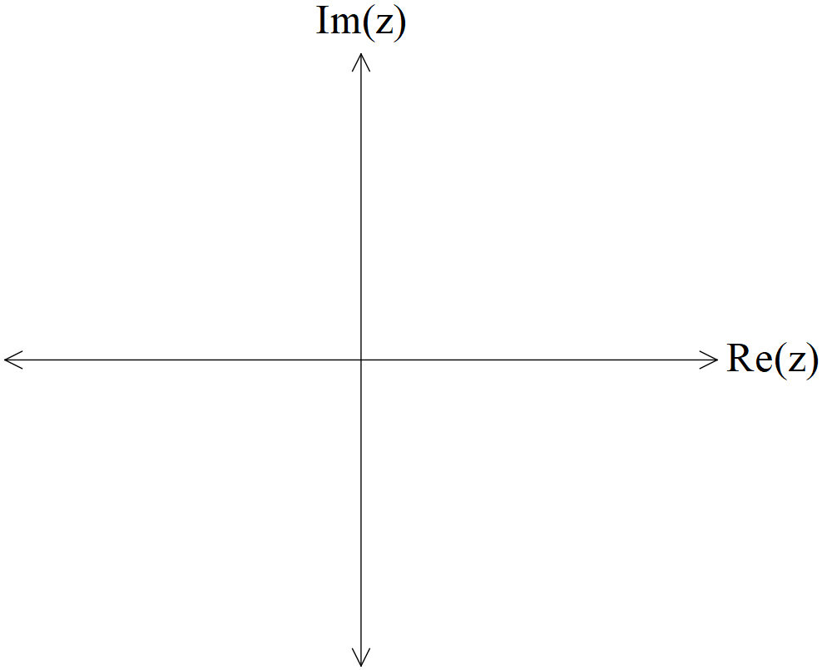

1.  (2 marks)



Q9 Cont-

The solution to , where  are real constants, is given by .

1. Determine the exact values of . (4 marks)

**Question 10 (9 marks)**

Consider an electronics company that manufactures transistors with weights that forms a Normal distribution of mean 95 milligrams and a standard deviation of 23 milligrams. A sample of 75 transistors is taken and the sample mean weightof this sample of 75 is examined.

1. State the distribution with its mean and standard deviation. (3 marks)
2. Determine the probability that the sample mean is greater than 102 milligrams.

(2 marks)

1. A new sample size is chosen such that the probability that the sample mean is no more than 12 milligrams from 95 milligrams is 92%. Determine the new sample size.

(4 marks)

**Question 11 (7 marks)**

Consider the graph of  and the tangent line drawn at .

The area between the graph and the tangent is shaded as seen below.

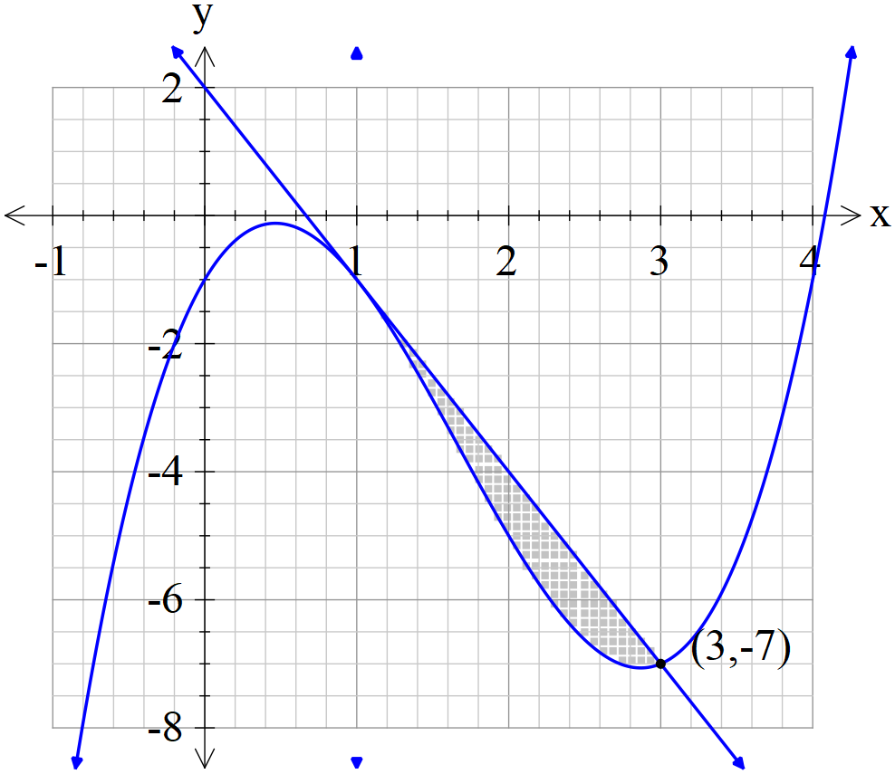

1. Determine the shaded area. (Exact) (3 marks)

The shaded area is then revolved around the x axis.

1. Determine the exact volume of the resulting solid. (4 marks)

**Question 12 (7 marks)**

A super-heated metal rod cools according to the differential equation  where  is a constant representing the room temperature and  is a constant.  represents the temperature of the rod in degrees at time  seconds that the rod has been left in the room,

1. Determine an expression for the temperature at **any time** in terms of  and the constants. (4 marks)

It is known that the room temperature is 18 degrees and that the initial temperature is 65 degrees and .

1. Determine the time taken for the temperature of the rod to cool to 32 degrees.

(3 marks)

**Question 13 (7 marks)**

Consider the graph of the function  as shown below.

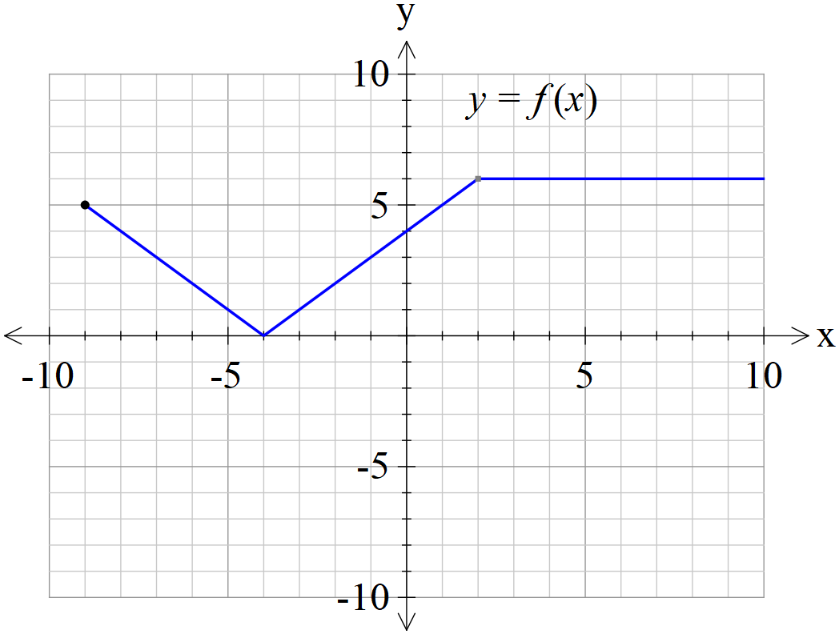

1. Sketch the graph  on the axes below. (3 marks)

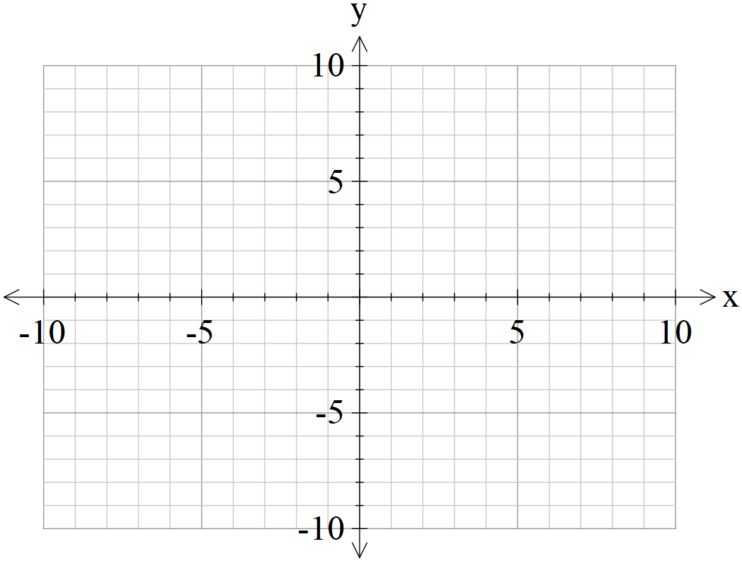

1. Sketch the graph  on the axes below. (4 marks)



**Question 14 (10 marks)**

An object with speed  and displacement from the origin at time  is moving with the following accelerations.

1.  with  at . Determine the speed at . (3 marks)

1.  with  at . Determine the speed at . (3 marks)

An object is known to be moving with **speed** given by the equation 

.

1. If initially at the origin, determine the displacement from the origin, , at any time .

(Hint- use the substitution ) (4 marks)

**Question 15 (9 marks)**

A particle moves according to the following parametric equations.

 at time t seconds,  in metres.

1. Determine the cartesian equation. (3 marks)
2. Determine the equation of the tangent when . (3 marks)
3. Determine  when . (Simplify) (3 marks)

**Question 16 (8 marks)**

A sample of 25 tyres are used to determine the population mean weight of the type of tyre.

The following 95% confidence interval was calculated kg.

1. Determine the sample mean. (1 mark)
2. Determine the sample standard deviation. (3 marks)

State whether the following changes would increase or decrease the width of the confidence interval and give a reason.

1. Have a sample size greater than 25 tyres. (1 mark)
2. Calculate a 90% confidence interval. (1 mark)
3. Using a smaller sample standard deviation. (1 mark)
4. If 60 lots of 95% confidence interval were calculated, what number would you expect to contain the true population mean? (1 mark)

**Question 17 (8 marks)**

The position vector of a particle at time,  seconds, is given by  metres.

The path of the particle is shown as follows.

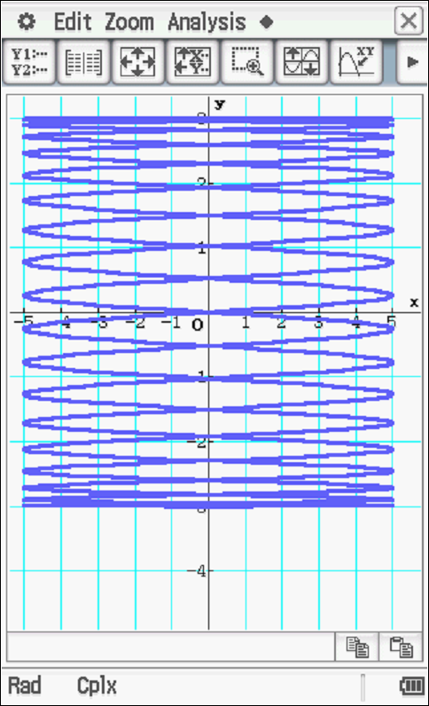

1. State the initial position and label on the path above. (1 mark)
2. Determine the acceleration when  seconds. (3 marks)
3. Explain why the time of one complete circuit is  seconds. (2 marks)
4. Determine the distance travelled in one circuit. (2 marks)

**Question 18 (9 marks)**

1. Determine all positive values of the constant for the function  so that  will satisfy the differential equation . (3 marks)
2. The section of the curve of the function in the interval  is rotated about the x axis. Show that for the value of found in part a above, the volume of the solid produced after one rotation is. (3 marks)
3. Show that if  is the area under the curve  in the interval , then . (3 marks)

**Question 19 (7 marks)**

Two rockets A & B have initial positions km at noon. They both move with constant velocities km/h.

1. The two rockets leave a smoke trail that stays in the air for a long period of time. Determine the point (if any) where the smoke trails cross. (3 marks)
2. Determine the shortest distance between the two rockets and the time that this occurs.

(4 marks)

**Question 20 (7 marks)**

Consider the quadrilateral  with fixed side lengths . Let  be opposite angles.

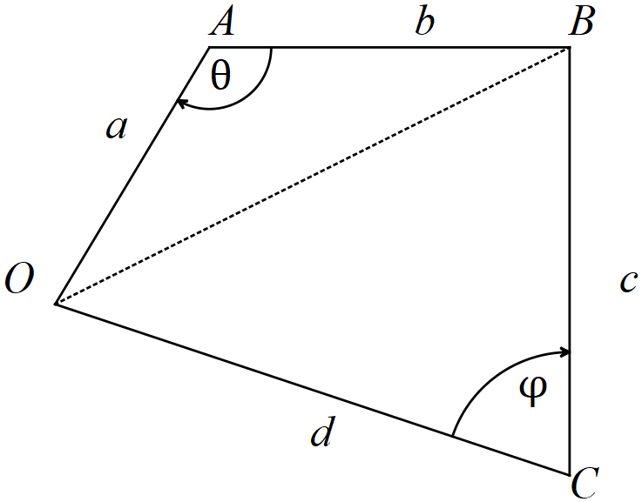

1. Show that the area of the quadrilateral is . (1 mark)
2. By considering the common side  to both triangles above, show that .

(3 marks)

1. Hence show **using calculus** that the area of the quadrilateral is optimal, , when opposite angles are supplementary, . (3 marks)

Additional working space

Question number:

Additional working space

Question number:

Additional working space

Question number:

Additional working space

Question number: